Web Software

Sheet 1

1. Draw a sequence diagram for the following:
   1. Online customer can search book catalog, view description of a selected book, add book to shopping cart, do checkout.

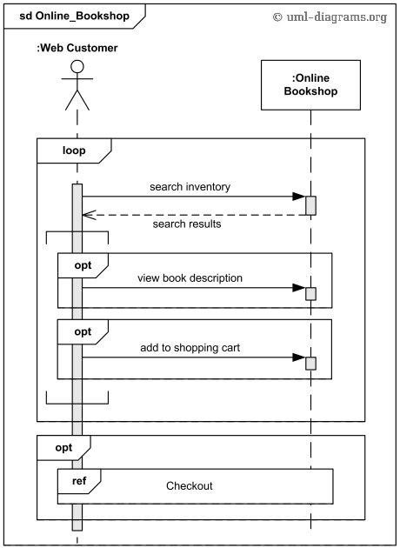

* 1. An emotion based music player:
     1. Firstly the application is opened by the user.
     2. The device then gets access to the web cam.
     3. The webcam captures the image of the user.
     4. The device uses algorithms to detect the face and predict the mood.
     5. It then requests database for dictionary of possible moods.
     6. The mood is retrieved from the database.
     7. The mood is displayed to the user.
     8. The music is requested from the database.
     9. The playlist is generated and finally shown to the user.

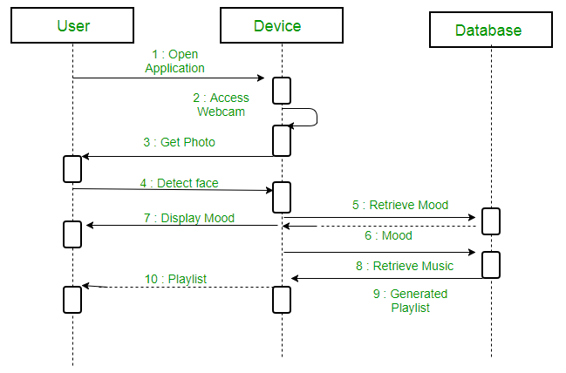

* 1. Show the interactions between a user and a ticket booking system in booking a seat. It consists of mainly four parts: The actor, which is the user, the boundary object ‘interface', the controller object ‘main Controller' and two entity objects routes and route.

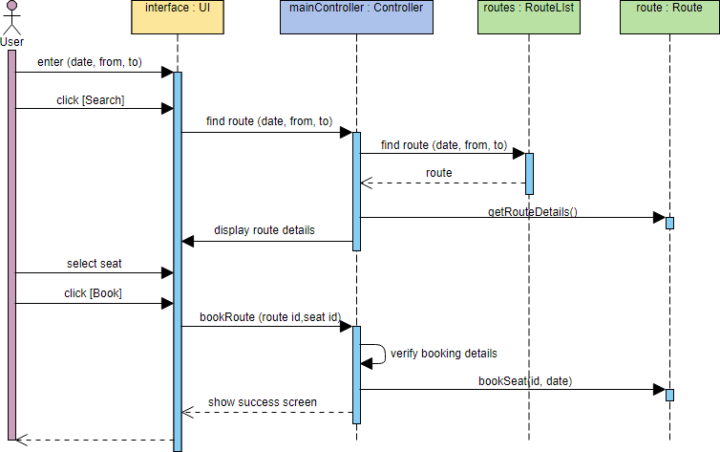

1. Draw a state diagram for the following:
   1. Draw a state chart to describe one’s marital status.

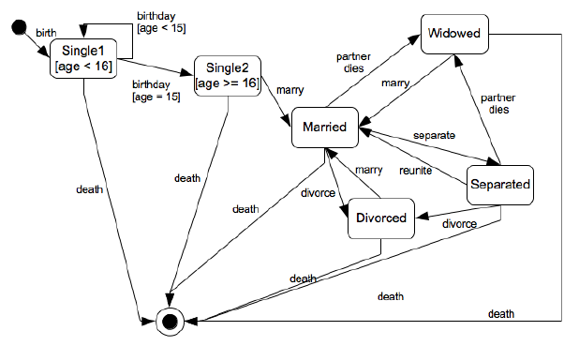

* 1. Draw a state chart to describe the process of booking a set for some special event.

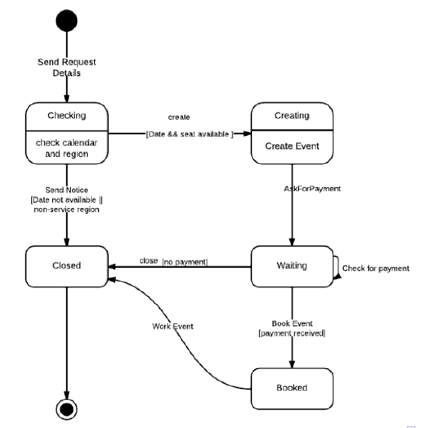

1. Draw a class diagram for the following:
   1. A company consists of departments. Departments are located in one or more offices. One office acts as headquarter. Each department has a manager who is recruited from the set of employees.

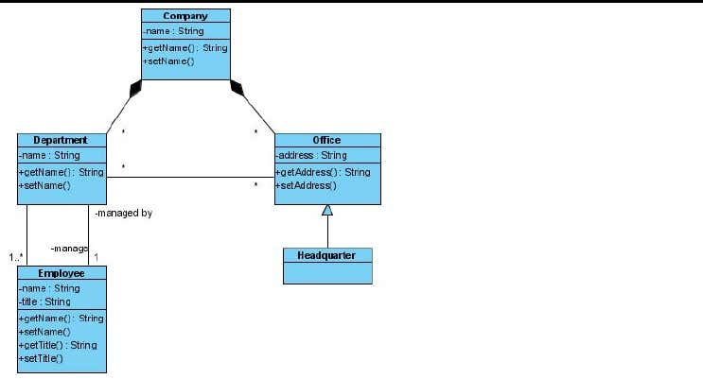

* 1. A house may have any number of pets living in it •The two possible types of pets that can live in a house are dogs and cats •Each dog or cat has a name •An animal’s house is its one and only home •You can ell an animal to make noise and it will do its thing

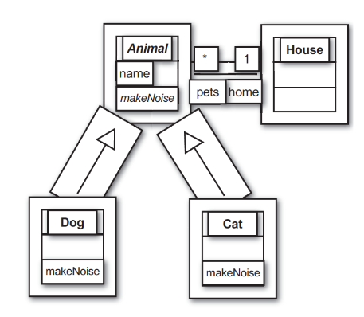

1. Draw an ERD for the following:

You are required to create a conceptual data model of the data requirements for a company that

specializes in IT training. The Company has 30 instructors and can handle up to 100 trainees per training

session. The Company o;ers <ve advanced technology courses, each of which is taught by a teaching

team of two or more instructors. Each instructor is assigned to a maximum of two teaching teams or

may be assigned to do research. Each trainee undertakes one advanced technology course per training

session.

(a) Idenfy the main enty types for the company.

(b) Idenfy the main relaonship types and specify the mulplicity for each relaonship. State any

assumpons you make about the data.

(c) Using your answers for (a) and (b), draw a single ER diagram to represent the data requirements

for the company.

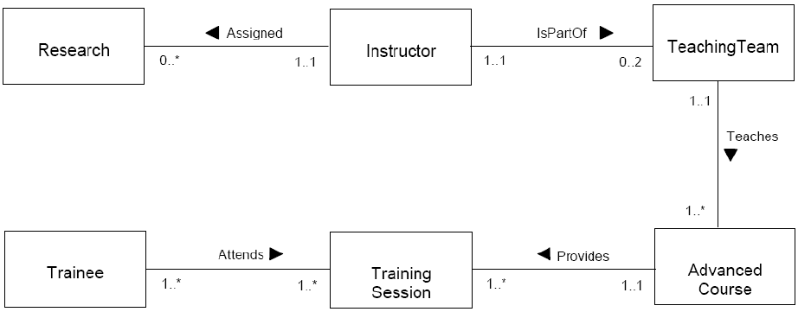

Read the following case study, which describes the data requirements for a video rental company. The

video rental company has several branches throughout the USA. The data held on each branch is the

branch address made up of street, city, state, and zip code, and the telephone number. Each branch is

given a branch number, which is unique throughout the company. Each branch is allocated sta;, which

includes a Manager. The Manager is responsible for the day-today running of a given branch. The data

held on a member of sta; is his or her name, posion, and salary. Each member of sta; is given a sta;

number, which is unique throughout the company. Each branch has a stock of videos. The data held on a

video is the catalog number, video number, tle, category, daily rental, cost, status, and the names of

the main actors, and the director. The catalog number uniquely iden<es each video. However, in most

cases, there are several copies of each video at a branch, and the individual copies are iden<ed using

the video number. A video is given a category such as Acon, Adult, Children, Drama, Horror, or Sci-Fi.

The status indicates whether a speci<c copy of a video is available for rent. Before hiring a video from

the company, a customer must <rst register as a member of a local branch. The data held on a member

is the <rst and last name, address, and the date that the member registered at a branch. Each member is

given a member number, which is unique throughout all branches of the company. Once registered, a

member is free to rent videos, up to maximum of ten at any one me. The data held on each video

rented is the rental number, the full name and number of the member, the video number, tle, and

daily rental, and the date the video is rented out and date returned. The rental number is unique

throughout the company.

a) Idenfy the main enty types of the video rental company.

b) Idenfy the main relaonship types between the enty types described in (a) and represent

each relaonship as an ER diagram.

c) Determine the mulplicity constraints for each relaonship described in (b). Represent the

mulplicity for each relaonship in the ER diagrams created in (b).

d) Idenfy a1ributes and associate them with enty or relaonship types. Represent each a1ribute

in the ER diagrams created in (c).

e) Determine candidate and primary key a1ributes for each (strong) enty type.

f) Using your answers (a) to (e) a1empt to represent the data requirements of the video rental

company as a single ER diagram. State any assumpons necessary to support your design.

ANSWER:

